

Installation of the MapPoint Software

Note: Depending upon the security features in place at your hotel some or all of these steps may require that an IT person with administrative rights be logged on to the PC where these tasks are performed.

Perform the following steps:
- Run the MapPoint Setup Program
- Register the Location of the MapPoint Data
- Create the Base Map Template file
- Enter your Hotel Starting Location Information

1.) Run the MapPoint Setup Program

Follow the instructions included with the software. We recommend that you do a “Complete” installation including copying the mapping data to the local PC or to a network location. This will make rendering the maps more efficient.

2.) Register the Location of the MapPoint Data

You should use the regedit.exe utility to register the data location. From Start Menu select Run and key in “regedit” and press enter.

Navigate to HKEY_CURRENT_USER\Software\Microsoft\MapPoint\xx.0\USA (where xx is the version number of your installed MapPoint.

NOTE: For the European Version of MapPoint replace the USA with EUR.

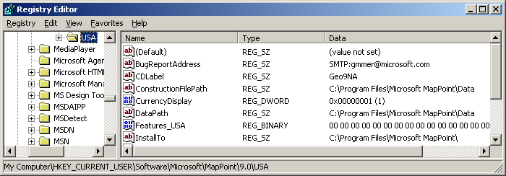

Double-click on the DataPath key

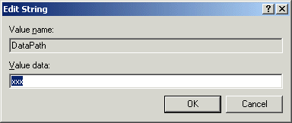

Key in the location of the MapPoint Data installation

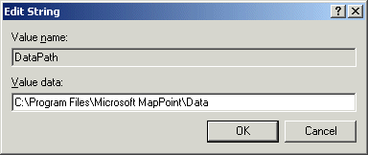

And press OK. Exit the Registry Editor application.

3.) Create the Base Map Template File

Launch Microsoft MapPoint. Select Tools from the Menu Bar

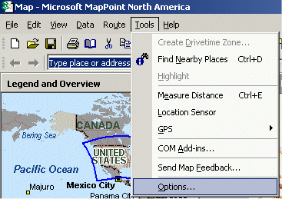

Click on Options . . .

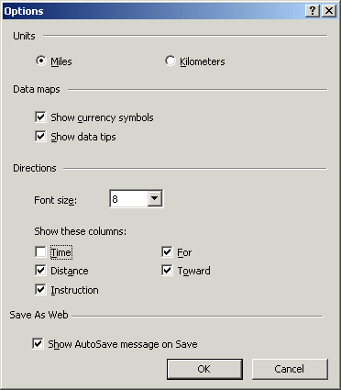

Uncheck the Time checkbox and click OK.
Select View from the Menu Bar

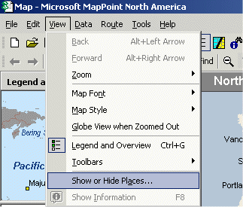

Click on Show or Hide Places . . . Click on the Places tab

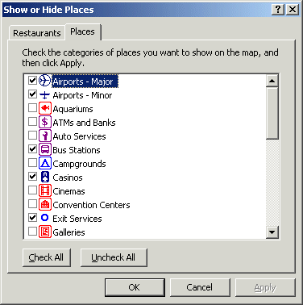

Click on the Uncheck All button. Click on the Restaurants tab.

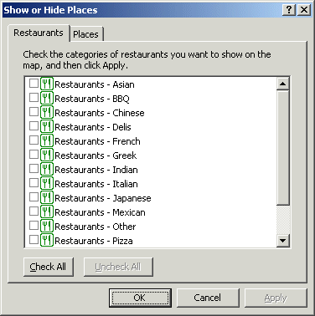

Click on the Uncheck All button. Click OK.

Select File / Save As … from the Menu Bar

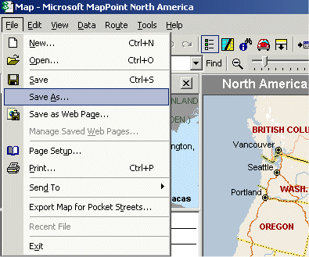

Navigate to the Network Database directory.

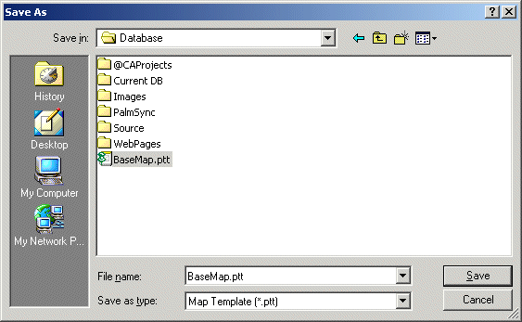

Click on BaseMap.ptt. Be certain that the Save as type is Map Template. Click Save.

4.) Update the Registry Values in The Concierge Assistant

Launch The Concierge Assistant. Logon as an Authorized User. Click on the Administration tab, click on the Configuration Options button, click on the MapPoint Registry Values tab.

Using the Registry Editor (from Step 2) find the following Registry values and update the default values on the following display. Click on the Save button.

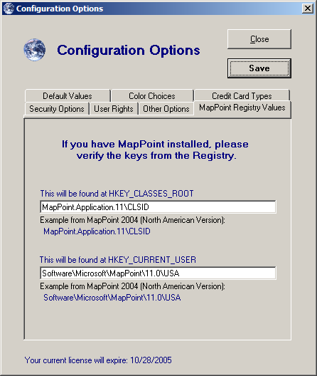

5.) Enter your Hotel Starting Location Information

On the Administration Tab click on the Create Your Own Map button.

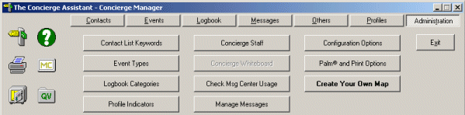

Click on the radio button labeled Use Your Address as the Starting Point

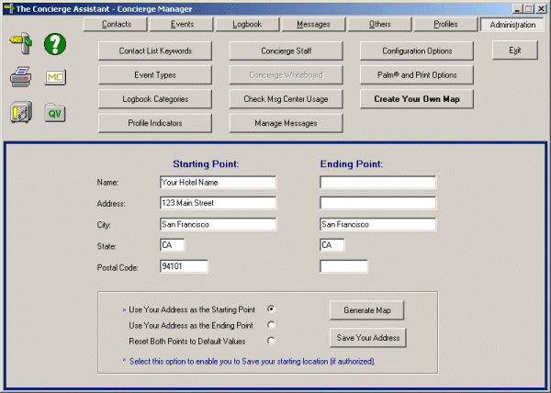

Key in your Hotel Name and Address information and Click on Save Your Address.

MapPoint is now ready to use.

